Measuring the regional dimension of innovation through an economic model based on rectifying technology audits.

LIST OF FIGURES CAPTURES:

FIG.1: RTA index

FIG. 2: Decision tree of the problem.

FIG.3: Expected cost for RTA Auditor B in sample size n.

Fig. 4 OSS and unity cost versus lot size N.

Fig. 5 OSS and unity cost versus cost ratio k1/k2 with k2=72.4.

Fig. 6 Oss and unity cost versus standard deviation σ.

Fig. 7 Oss and unity cost versus prior mean τ.

Fig. 8 Oss and unity cost versus prior standard deviation γ

Fig. 9: SMEs Configurable area partitioning

Fig. 10: RTA measurement system

Fig. 11: Remote server gathering data sent by clients mapping of a large area

Fig. 1 RTA Index
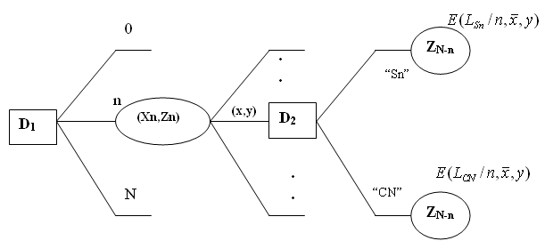

Fig.2 Decision tree of the problem

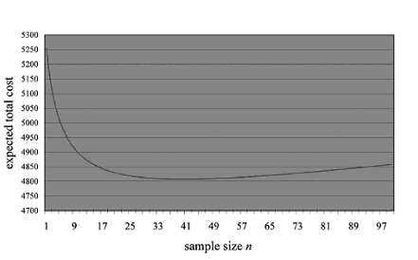
Fig. 3 Expected cost for RTA Auditor B in sample size n

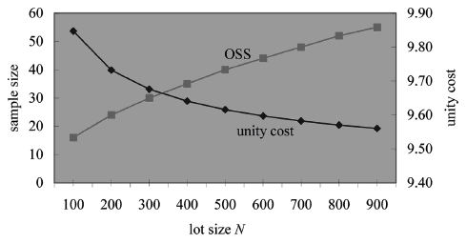
Fig. 4 OSS and unity cost versus lot size N.

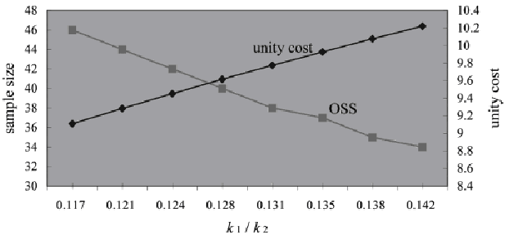

Fig. 5 OSS and unity cost versus cost ratio k1/k2 with k2=72.4

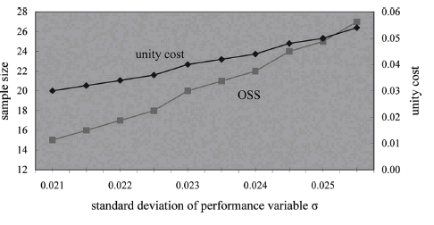

Fig. 6 Oss and unity cost versus standard deviation σ

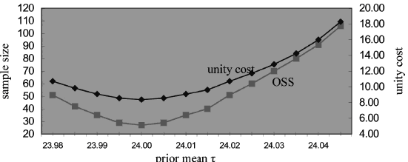

Fig. 7 Oss and unity cost versus prior mean τ

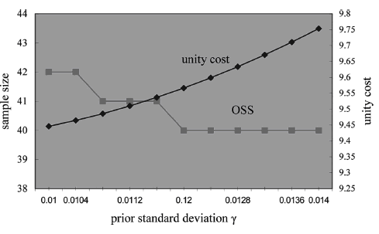

Fig. 8 Oss and unity cost versus prior standard deviation γ

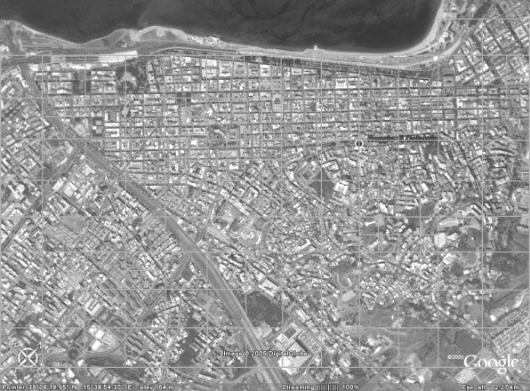

Fig. 9: SMEs Configurable area partitioning

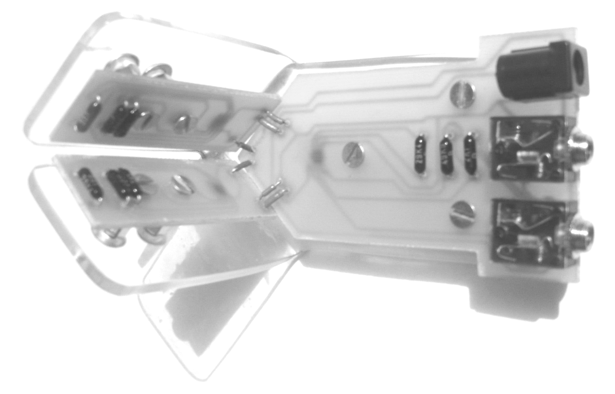
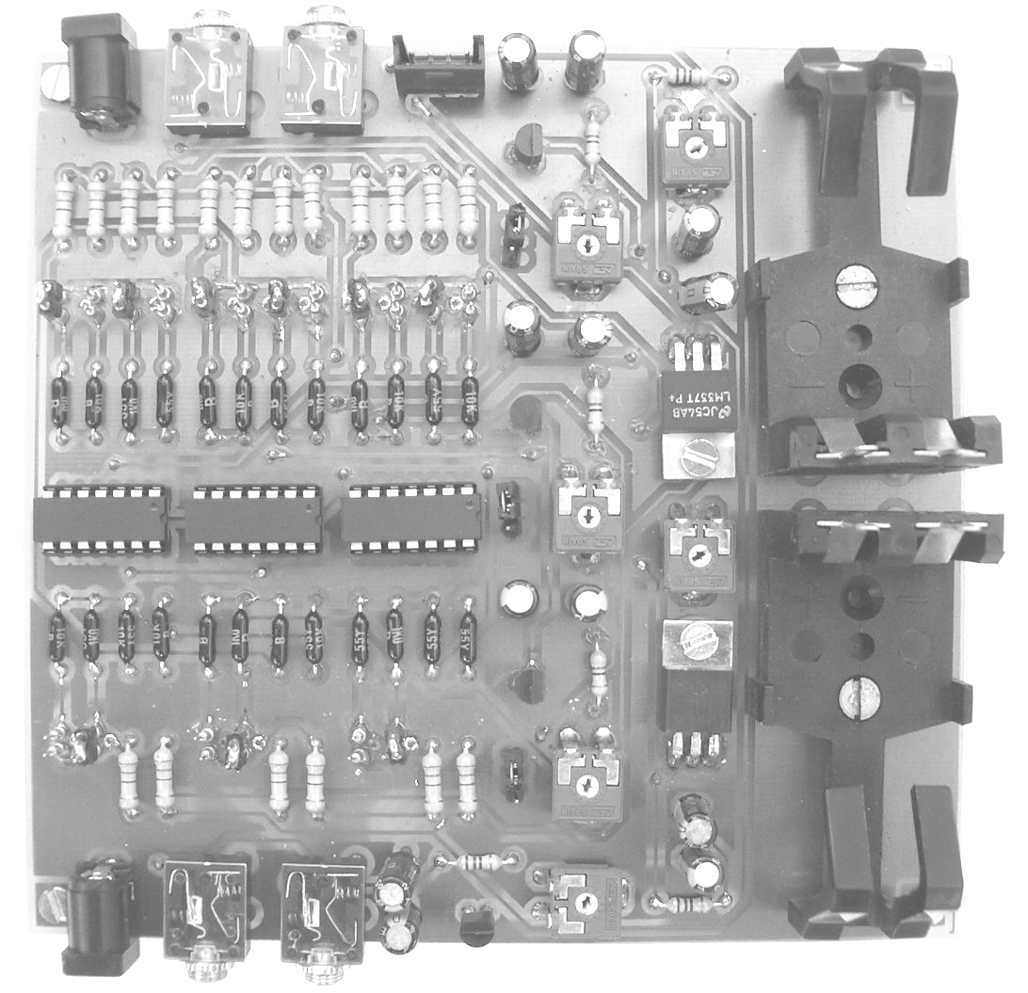

Fig. 10: RTA measurement system

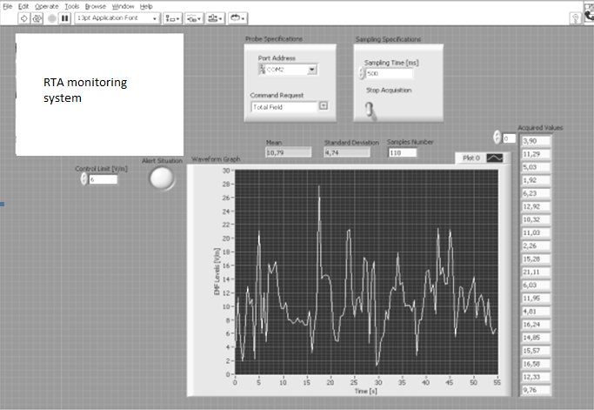

Fig. 11-: Remote server gathering RTA data sent by clients mapping of a large area

