Pic1- School Girls Abducted in Chibok, Borno State.
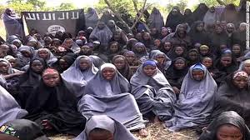
Source: www.premiumtimesng.com/

Pic 2- Nigerian troops searching for Boko Haram members in the Forest
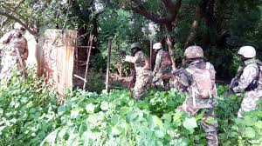
Source: www.premimutimesng.com/
Pic 3- Boko Haram Insurgents about to unleash an attack
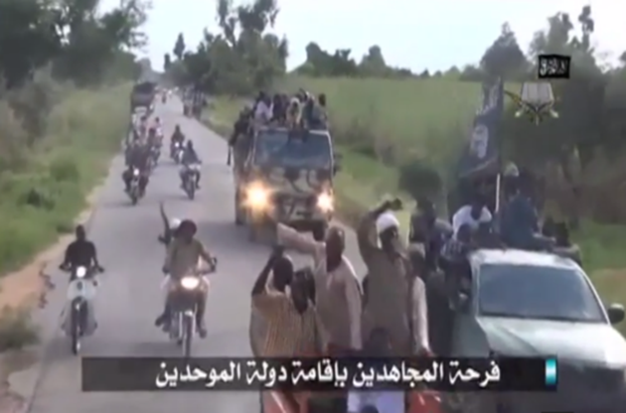
Source: www.premimutimesng.com/

Pic 4- Bomb Blast by Boko Haram Insurgents
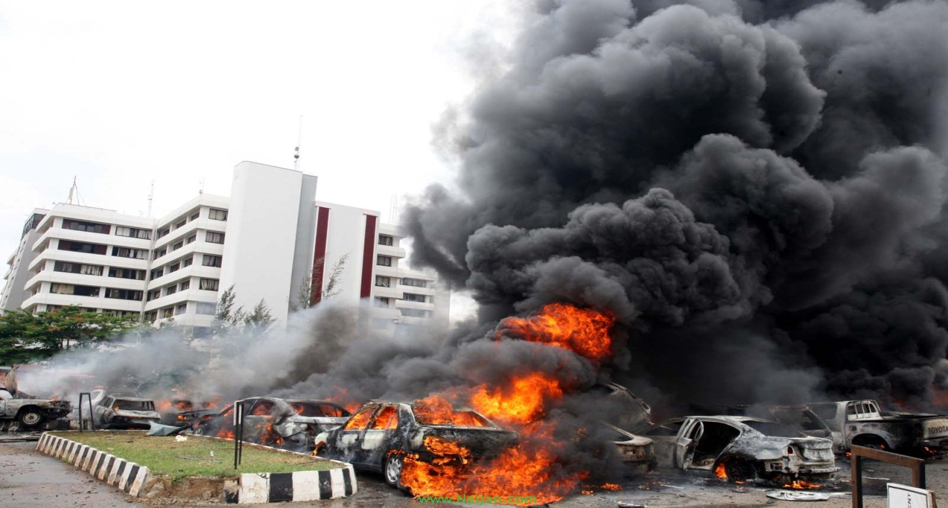
Source: www.nigerianobservernews.com/

