Critical Thinking Skills Incorporated in the Self-Learning Curriculum for Kindergartens

Dr. Raja Omar Bahatheg

Associate Professor

Educational Policies & Early Years

College of Education
King Saud University

rbahatheg@ksu.edu.sa

Abstract

The educational curriculums seek to develop the different types of thinking among students of both genders. The current research aims to finding out the inclusion of critical thinking skills' extent in the teacher's parameter guide questions and activities of the self-learning in Riyadh Kindergartens and educational units.

This research adopts the descriptive analytical curriculum; through educational units' lessons analysis, in terms of self-learning, duplications measurement and percentages of employing the critical thinking skills. The foregoing duplicates showed that the self-learning curriculum units do support the induction skills in relevant units (national, food, housing), observation skill (family, book, clothes), while it does not support credibility and conclusion skills, further the assumption skill scored weak rate in all units.

Key words: Educational units, self-learning curriculum, critical thinking.

This research has been supported by human studies researches center, scientific research deanship and King Saud University.

Introduction

B. Ali assures that the mental maturity helps children to build increasing understanding of things and incidents. Thence the child shall realize new expertise in methods that suit their maturity and cognitive structure through adapting their thinking method with this expertise, reorganizing such cognitive constructions in Schema system. Thence the child shall be able to re-establish cognitive balance of the surrounding environment. When the child is subject to educational stand or expertise that he cannot understand, his mind remains disturbed and imbalanced. Once the imbalance is solved via experiences adaptation, the child shall have new mental constructions and buildings that drive him to stability, gradual firmness and maturity. Accordingly, the child becomes able to adapt the new incidents that become an old expertise and further new experiences shall be added thereto.

On the other hand, Vygotsky explained to us the child's mental functions development and connecting thereof via his social communications with others. Thus, the children's mental skills and thinking methods are formed as a result of their participation in various activities in several social stands. The zone of proximal development (ZPD) is considered the basic stone of Vygotsky theory. What is meant by ZPD is the child ability to perform complicated missions alone, and the extent of achieving thereof with the mediator. In other words, the difference between child's missions' performance alone and co-performance with others; who are more experienced and ability of this child (Vygotsky 1987, Baroody, 2000; bahatheg 2010).

(V, Rogoff, 1990) has developed possible growth space concept ZPD, and explained the children role as active participants. She suggested Guided participation concept (GP). She discussed that children direction and participation is important for their thinking growth. In addition, same children play active role in their thinking growth and training. She further explained (Rogoff 1986) the adults' role to prepare the educational environment, work with children in verbal and non-verbal activities and helping them to understand how to behave in new stands. She also set out two methods to be used by adults while interacting with children in activities, which are implied and express regulations that allow knowing adults and their skills in helping children to translate the familiar information to applying thereof in new problem, expertise or learning. Moreover the adults' efficacy in structuring children learning cases is in line with children desire & participation in such interaction and they control their educational experiences.

Bronze cognitive upgrading form, added that relaying on environment in learning, and further the directed experiences as input to the thinking development and growth. Bronze assures the impact extent of technological progress on developing thinking functions and people thinking, since previous decades, differs than the current thinking method. Moreover, Bronze assures that the cultural effects are important in terms of cognitive development, work to develop the thinking ability. Bronze theory states that the social process is effective through which the child builds his new ideas and concepts. The child selects information and organizes the assumptions then adopts accurate decisions; which is the critical thinking core. (French 1992, and Rhode)

Critical Thinking

Thinking is considered one of the most important mental skills practiced by human on daily basis. Besides it is classified under the supreme mental operations. Views varied on allocating comprehensive definition to thinking term. (Costa & Kallick, 2008, 44) defined thinking to read "The mental processing of sensory inputs to form ideas, for the purpose of recognizing and judging the sensory stimuli". On the other hand, Jarwan (2007, 40) defines thinking to read "Series of mental activities performed by brain when it is subject to stimuli received via one of more senses". Both definitions agreed that thinking is mental activity and should be stimulated via senses methods. Zaytoom (2007) defines thinking "group of skills and mental processes used by the individual once searching for an answer for a question, solve problem, establish meaning or reaching original outcomes which are not known before. These processes and skills are educable through, specific educational processors."
Abu Jado 2007, p 472) defines thinking to read "Series of unseen mental activities performed by the brain, once excited via one or more senses to search for a meaning. Zaytoon added to thinking definition that it is searching of a problem, while Abu Jado added that thinking searches for position meaning. There are types of thinking; i.e. creative thinking – problems critical, logical and else solution. This research handles the critical thinking of children.

Jan Dewi consider critical thinking as reflective thinking (Fisher 2001, 2), which was seconded by many researchers; i.e. Qatami (2004, 123). He meant by critical thinking that it is reflective reasonable thinking focuses on individual believes or performs (Qatami 2004, 123)

In 1964, critical thinking was defined by Watson & Glaser) to be group of skills, knowledge and composite attitudes (in Richardson, 2005). (Beyer, 1985 defined critical thinking by purposeful, independent and logical thinking, that helps individual in terms of verifying information's accuracy and objectivity. (Lauren & Michael, 2004) refer that the critical thinking may be developed though directing the students attention to identify problems and necessary data; treating and interpreting the outcomes. Besides, assigning activities offered to students in form of causes requiring attention and challenging mental capabilities, through directing the students to think, reach the best solutions and exclude impossible or unsuitable solutions. (Stewart and Dempsey 2005: 81), who adopted defining USA Philosophy league (1990), desc0ribed the critical thinking by (Dispositions); i.e. lies on individual behavior that include several features such as ( Mind customs, thinking virtues, group of stands towards thinking operations. Whitehead, 2006 added that the critical thinking is a process that leads to drafting decisions and rules. This definition includes interpretation, analysis, assessment, inference and self -organization.

This research defines the critical thinking by logical thinking consisting of group of skills that help the individual to consider accuracy & objectivity in identifying & observing the problem then explaining its results and reaching the best solution thereto.

Critical thinking practiced by children and contents' analysis.

Assessment occupies the higher point in Bloom Hierarchy rating. Once the students learn assessment, they learn another method in thinking (Miller 2013, & Olthouse). The researcher also discussed whether the children are able to think of reasons and relationships in scientific thinking that allow them to performing experiments, designing and testing suppositions (Chen & Klahr, Nigam, 2004 & Klahr; 1999). Willingham, 2007 refers that the minor children who were noticed, use critical thinking, whilst trained scientists, sometimes, commit faults, even though it seem logical. Research studies conducted by Kennedy et. al. 1991), assured that ability of critical thinking improves with age, even the minors children may benefit from critical thinking regulations.

(Lipman, 1988), who looks for critical thinking skills as almost general, but he argues that teaching critical thinking must proceed side by side with teaching the basic skills; i.e. reading, writing, listening and talking. Also (Silva, 2008) repeats this point of view, under preservation, that cognition and thinking must be taught in the same time.(Case, 2005) added that critical thinking is a method, through which teaching purport and skills, that are included in the study curriculums, is possible.
While (Pithers & Soden, 2000) refuse the view that states that critical thinking may be taught as separate subject, instead of such, we have to look to critical thinking as a mean to learn and teach in any domain.

(Tobin & Capie, 1983) referred that the scientific thinking, critical thinking and method of problems solving are names for one thing; represented by one factor, which is using mental processes that care of observations, predicting, assumptions and testing; all are referred to as science processes. Al Harahsheh (2014) added that critical thinking respects the students' independence, thus we have to encourage them to discover information, using knowledge and skills to think by them. Abrami et.al.,2008) and others say that the teachers have to teach critical thinking, whether through merging thereof in the academic content via educational subjects or via teaching critical thinking skills as separate component, and show thereof as implied objective in the curriculum.

There are various methods to teach the critical thinking, including thereof via the academic curriculums, and considering it a process in defining, applying, analyzing, or assessing the information; collected or shall be collected from observance, expertise or communicating (Center for critical thinking, 2004). (Ramsay et.al.2009) and others state that the learners shall understand raising arguments concept, classifying beneficial or otherwise data, explaining types of induction relationships and analyzing ability.

Researches discussed the minor children issue who must participate in many knowledge processes, performed by adults, and the respective researches concluded that there is a space for critical thinking in the academic curriculums set out for primary schools (Gelman & Markman, 1986). Silva 2008) assured that there is not specific age when children are ready to learn and know more complicated thinking methods. Nabhan 2008) discussed that critical thinking could be promoted through teaching various subjects, and training students on critical thinking. The foregoing could be achieved by providing knowledge and training on comparative, observation, classification, interpreting, criticizing, Hypotheses' Formulation, collecting data and analyzing processes. Ibrahim (2005) assured that teaching the critical thinking comes through curriculums, which shall include logical methods and the thinking is to be educational output.

Studies differed on critical thinking importance among teachers who interact with children and work to promote children critical thinking issue. Hashim 2002) studied researches handling thinking scope in Kindergartens stage until advanced stages in Malaysia. The study outcomes showed that that the relevant studies were done to improve and understand teachers' skills in both critical and creative thinking. Respective Teachers appreciated the critical thinking importance in teaching children and students Owais 2009) studied the efficacy of training Kindergartens teachers to develop children thinking skills. The study outcomes assured the program efficacy, as teachers performance is improved in post-test which indicates their acquisition knowledge and methods to develop children thinking skills.

Caillard, 1993) handled study on suitability extent of academic curriculums in Kindergartens, and its tools used therein to meet growth needs of supreme skills in the kindergarten. The study found out that there is conflict between curriculum basic rules, activities, purport, shape and required skills from children. He suggested to amend the curriculum and carrying out its subjects to achieve supreme skills of kindergarten children. Besides Study of Collier, Veerman & cuenther, 2002) tackled the developing critical thinking skills through applying variable strategies to develop students skills in critical thinking. Study sample was selected from early childhood, kindergartens and 8th. class. The study witnessed notable improvement in critical thinking of most of the students and it is necessary to highlight the teachers' efforts in teaching thinking in a meaningful mode. Further the study reached at the fact that the students developed their discussing methods and their answers logic.

Moreover, Al Mansour study (2005) assured the thinking skills programs efficacy to problems solving. The study noticed samples individuals' performance improvement; who are students in the primary stage, in problems solving tests. Azzoz 2008 also studied the efficacy of some scientific activities in promoting innovative thinking abilities of kindergarten children sample. Also the respective outcomes showed difference of statistical significant between both experimental & controlling groups' total mark of innovative & critical thinking abilities. The forgoing has been seconded by ex-study of (Mansi 2000) in terms of some scientific activities impact in innovative thinking ability growth of kindergarten children. The study seconded the scientific activities efficacy in developing creative thinking abilities of the experimental sample children.

Maguinness C. et al 2000) prepared three years study to identify the impact of children thinking skills development and reached at the necessity to developing the decision's making skills, problems solving, critical thinking & creative thinking of children. Lampert, 2011) designed program for arts, that enhances critical thinking skills among ten children in the primary stage through engaging students in survey-based art lessons. The test outcomes showed in-kind increase in critical thinking marks' average of the children.

Research Problem

The cognitive theories focused on method of explaining the child's cognitive construction, thinking growth method, external environment and cultural impact as well as social interactions. Each of Biyajah & Fegatoski, assured the importance of constructing the child thinking since childhood. Kuhu, 2005) referred to the necessity that class environment is to be encouraging factor for critical thinking, whether learning is performed in interacting image or individually. Student's possession of critical thinking skills helps to form outputs he seeks for. Bose, 2012) discussed the importance of physical class environment which should be taken into account by teachers. Such matter helps the child to grow, creates learning opportunities and further caring of activities and purport of any curriculum in such important stage. Fu, 2010) stressed the necessity that teachers in childhood stages shall help the children on logical scientific thinking, identifying reasons, using various open questions, offering feedback and building cognitive growth in educational and interactive environment. Self-learning curriculum is the accredited curriculum by the Ministry of education, as well as at governmental kindergartens in KSA. Therefore, this research shall focus on the inclusion extent of critical thinking skills in the self-learning curriculum questions; represented by its educational units.

Main question is represented by

- What is the inclusion extent of critical thinking skills in the self-learning curriculum questions set out for children kindergartens?

Research Definitions:

- Questions

Darwazah 244, 2000) defined thereof as exciting object requires re-action and response. The foregoing requires from the learner some thinking, examining the educational subject in hand and retrieves saved information in his memory via a way that helps him to offer accurate answer."

This research adopts such definition.

Critical Thinking

This research defines the critical thinking, in procedural manner, to be logical thinking consisting of group of skills that help the individual, to seek accuracy and objectively, while specifying the problem, observing, explaining its outcomes and lastly reaching to the best solutions thereof.

Research Objective

This research aims to identify inclusion extent of critical thinking skills in the self-learning curriculum questions directed to children kindergartens, (2005).

Research Importance

This research importance lies on the following points

- The minority of studies, which tackle, critical thinking at pre-primary stage's children.
- Supplying objective procedural data to those who are engaged in children kindergartens, particularly in KSA and Arab world in general; i.e. planners, designers, implementers & software developers. The foregoing is intended in order to identify critical thinking skills included in the self-learning curriculum, to take thereof in account once developing the curriculum.
- Bring the teachers attention to thinking skills in general and critical thinking skills in particular, which the educational units include in self-learning curriculum.

Research Limits

The research is limited to analyzing the questions of educational units in terms of self-learning curriculum at children kindergartens (2005), in Saudi Ministry of Education.

Self-Learning Curriculum

This curriculum is used by KSA kindergartens' teachers. It has been developed in 1994, pursuant to agreement between Girls educating body and Arab Gulf programs. The curriculum includes provision on the educational frames, which should be used by those teachers during their educational process. It depends, basically, on teaching Islam, as major educational aims in KSA. The self-learning curriculum contains teacher's guidebook and five books for the educational units; water, sand, food, house and hands). The sixth book contains other five educational units; (clothes, family, friends, health-safety and my book).

This curriculum was re-developed in 2005, the educational unites remained and simple part was added relating to method of reading and writing. The books contain general objectives of the unit, special objectives, basic concepts, tools, means used in lessons as well as detailed description of the activities which the teacher shall set out during the daily program. This curriculum depends on preparing educational environment by the teacher in academic classes, which is responsible to create educational basis for children, helping them in play and learn by themselves. Also the self-learning curriculum followed self-learning method that focuses on self-activity of children in a way that each child interacts and deals with targeted educational games which are available at its educational environment that helps him to discover his abilities and developing thereof, in a way that suits its growth.

Questions

Questions are considered one of the school book components and a main communicative tool between teacher and learner. Good questions work to excite and diversify the learners thinking (Akbo Saidi & Sulieman 2011: 402.). Also, the educational activities inclusion of a factor, from among factors, that form the curriculums, is considered a mental and manual effort in forming learner expertise and amend its behavior modes, which both learners and teachers perform to achieve the educational goals inside the school, (hashemi and Muhsen 2009:43). Many researchers in thinking field, such as (Newman 1978, 7) assured that the educational activities must be included in the educational curriculums that allow the learner to practice thinking and creation to achieve integrated growth. Newman Also emphasized on the science as an activity practiced by the learner rather than being group of reality acquired by the learner to display thereof in written examination, and further it is not experiments series to be performed only in a Lab.

Critical thinking skills

The researchers discussed critical thinking skills or components, which should be included in the curriculums. (Paul Scriven, 1987) divided the critical thinking skills as follows:
- Ability to interpret
- Assessment
- Observation
- Communicating
- Available Information
- Ability to argue
While, Udall & Daniels, 1991) sort out the critical thinking skills as follows:

- Induction
- Conclusion
- Assessment

Watson & Glasere, 1994) added to such sorting out the main skills of the critical thinking as follows:

- Assumptions knowledge
- Conclusion
- Interpretation
- Extraction
- Arguments evaluating

Besides, Brink-Bdgen, 2000) states on the importance of including problem that defining and arguments analysis.
Thomson 2002) added interpretation skills or indicating reasons.

Worrow, 2004) added asking questions

Cottrell, 2005 added other critical thinking skills; i.e. meditation and evaluation.

Wilson, 2000) referred that most of critical thinking definitions agree on basic skills, and it include collecting and analyzing information, solve problems, generate new ideas, assessing options, and decision making.

Al Sharqi 2005) divided critical thinking skills into:

- Assumptions knowledge
- Interpretation
- Evaluating the discussions
- Extraction
- Conclusion

The researcher are too close in dividing critical thinking skills, as extraction, interpretation and evaluation are used in most of the relevant definitions.

Castile, 2009), in Portsmouth University, sets out six components of critical thinking skills; i.e. attainment, interpretating, application, generating, evaluating and justification.

The current research displays, in detail, Facione's classification as well as Watson classification. Facione defined six critical thinking skills as follows:

- Logical interpretation skill: represented by individual ability to present justifications or logical explanation of an incident or problem, and extracting certain result (an image of cause and result), on the light of available facts that the bind accepts. It is mental process aiming to give a meaning on student life expertise and extracting such meaning. The student, once he presents explanation for an expertise, he explains the meaning extracted from its available information, (Obaid and Afanah 2003, p 55).
- Analysis skill – Assumptions: It is the ability to define assumptions that fit to solve the problem or opinion in issue at hand. Sharqi defined thereof, by the ability to examine facts and data included in certain subject, in a way that enables the person to issue its opinion on such subject, (Obaid & Afanah 2003, p 53).
- Ability to evaluate discussions (assessing the evidences) skill: This represents the ability to distinguish between strength and weakness points in adjudicating certain case or incident in order to offer justifications and extracting result on the light of available evidences and facts that are mentally accepted, (Obaid & Afanah 2003)
- Conclusion skill: This skill seeks to achieve more information to relevant person on the issue at hand. Moreover, it seeks to analyzing the relationship among things and, further, relationship among various matters. This skill moves from definition or rule to example, from general to private or from whole to the part. Conclusion means ability to analyze the offered data. We also may define conclusion to be skill or mental ability through which we employ our knowledge and information to reach at absent or unclear result. Also it is defined by the mental ability via which the learner uses all his expertise and available information to display result accuracy or otherwise, or explaining unforeseen side, based on in its engagement to offered information ( Obaid and Afanah 2003, p.53)
- Explanation – inference skill: Ability to extract new information based on knowledge or presented information. Further, linking ability and allocating relationship among certain offered facts and forms from one side and other forms from other side. The forgoing shall determine if the result is derived from such facts, forms or otherwise, regardless the offered facts credibility or the individual stand there from. (Darwish and Harb 2007, p.8
- Self-organization skill: means the ability to inquire and make sure of ideas' credibility or organization.

Watson & Glaser, 1994) classified critical thinking as follows:

- Identifying assumptions: That means the ability to distinguish between specific information's credibility or otherwise, reality and opinion, and the purpose of offered information.
- Interpretation: That means the ability to define the problem, identifying the logical interpretations and determining whether information and outcomes are based on certain acceptable information or otherwise.
- Extraction: that refers to individual ability to define some outcomes originating from certain facts; noticed or supposed, and having the ability to realize the outcome credibility or otherwise on the light of facts at hand.
- Conclusion: It refers to the individual ability to specify some outcomes originated from previous information.
- Arguments evaluation: Means individual ability to evaluate the idea or refuse thereof, distinguish between basic & secondary sources, strong and weak arguments and determining the information adequacy extent.

Upon reviewing the previous classifications of critical thinking skills, this research adopts the following classifications as to critical thinking:

- Induction (Interpretation): It is represented by individual ability to explain the meaning – present examples- ability to extract main idea-interpretation- (Who, when, where, what) to solve the problem
- Conclusion: Means the individual ability to define and know interconnections as well as how to reach an information or outcome via indirect observation.
- Observation: Means the individual ability to classify, compare or match and further figuring out the components.
- Assumptions: (Inference) which is the individual ability to present opinion, defining relations, probability, solve questions relating to (What IF)
- Credibility: (assessment-extracting), means the individual ability to mention evidences, proves and knowing the sources and method to making sure of information and sources thereof.

Research's Methodology and Sample

This research shall adopt the content analysis method, which is quantitative organized method. Such method works to analyze the vocal material particulars; i.e. analyzing all symbolic connection modes and identify the subjects; which targeted category cares of. It should be completed pursuant to specific agreed upon categories. The researcher role is to find out cases number or duplications in each category to achieve specific and accurate description thereto. Such description must be quantitative at the end, as it depends on number of duplications in each analysis category.

Content analysis method is employed to perform comparisons in order to clarify differences in the scientific subject and applicability of the scientific content, in schoolbooks, to targeted educational goals, (Obaidat, Kayed, Adas 2011). This research analyzes questions of self-learning curriculum units consisting of six basic books; the units are water, food, sand, house, hands and the seventh book include five summarized units which are clothes, family, friends, my safety and health, my book and the unit which was added is My homeland. Three lessons shall be analyzed for each unit by selecting lesson in the introduction and lesson in middle of the unit and finally lesson before the unit end.

Steps adopted in conducting the research

- I have read researchers classification of critical thinking skills
- Specifying the critical thinking skills in the current research.
- Analyzing two lessons from different units and applying thereof to external analysis to figure out the researcher stability on employing skills and applying thereof to questions.
- Performing suitable statistical analysis
- Showing outcomes, explaining thereof and suggesting suitable recommendations.

Tool stability

The researcher with external analyst discussed the critical thinking skills and applied thereof, solely, on two lessons from different units, then calculating stability coefficient through calculating correlation coefficient among duplicate results and percentages of both lessons, which registered (0.91), high value allows the researcher to perform analysis by herself.

Presenting and explaining the results

This research employed descriptive statistics to reply the research main question. Duplication schedule and percentages of the five critical thinking skills were used.

This research raised a question; extent of including self-learning curriculum questions, represented by its educational units, on critical thinking skills?
Table (1) presents total duplications and percentage of each critical thinking skill and educational units of the self-learning curriculum.

Table No. (1)
Total duplications of critical thinking skills and its percentages

The table shows that the most critical thinking skills employed by the raised questions in the educational units of learning curriculum is observation skill,
Unit – curriculum | Induction | Conclusion | Observation | Credibility | Suppositions | Duplication | %
Hands unit | 12 | - | 13 | - | - | 25 | 8.0%
Water unit | 13 | 5 | 4 | - | 3 | 25 | 8.0%
Food unit | 20 | 2 | 11 | 1 | 4 | 38 | 12.2%
Sand unit | 12 | - | 4 | - | 7 | 23 | 7.4%
Clothes unit | 10 | 2 | 14 | - | 3 | 29 | 9.3%
House unit | 15 | - | 7 | - | 6 | 28 | 9.00%
My health -safety | 8 | - | 12 | - | 5 | 25 | 8.00%
My book | 3 | - | 22 | - | 3 | 28 | 9.00%
My home country | 29 | 0 | 7 | 0 | 7 | 43 | 13.8%
My Friends unit | 5 | 0 | 15 | 0 | 0 | 20 | 6.4%
Family unit | 4 | 0 | 23 | 0 | 0 | 27 | 8.7%
Duplication | 131 | 9 | 132 | 1 | 38 | 311 | 100%
Percentages | 42.1% | 2.9% | 42.4% | 0.3% | 12.2% | 311 | 100%

As it acquired highest duplications at 42.4% followed by induction 42.1%. The same table offers suppositions skill decrease @ 12.2%, then conclusion skill @ 2.9%. The last rank comes credibility skill at 0.3%. We come to a conclusion that the educational units of self-learning skill focus on developing observation and induction skills in its questions, while suppositions, conclusion, credibility skills are ignored. This is confirmed by the following chart which clarifies the diagram of critical thinking skills in self-learning curriculum questions:

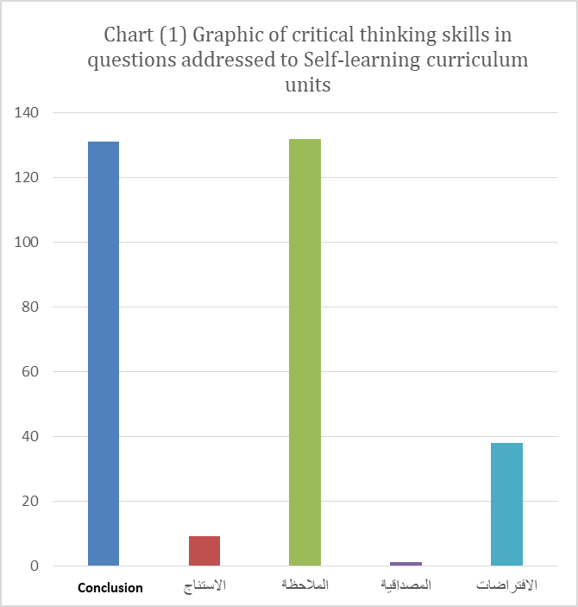
Induction
Observation
Credibility
Supposition
The critical thinking skills do not include series of sequence steps; i.e. solve problems, on the other hand, critical thinking skills are employed in conformity with the mission nature and further relevant thinking stand (Mossy & Petrosky, 1983). Each of Marzano and others (1998) as well as Michel, 2005) discussed that the teacher plays important role in assisting students to develop their critical thinking and training them through the positions as well as facilitating what is stipulated for in the curriculum. On the light of curriculum importance; forming reference frame for the teacher with all its aims, activities, questions and concepts, it is possible to link between it and thinking skills, in particular the critical thinking. Al Astal sat out a study focusing on critical thinking skills availability extent in the curriculum of literature and texts, and he found out that conclusion skill acquired the highest percentage, @ 37.2%, induction skill 22.7%, assumption skills 17.3% and finally observation skill scored 2.4%. The foregoing contradicts the current research outcomes, whereas conclusion skill scored law rate compared with observation and induction skills. Moreover, Al Astal does not agree to Al Hissan outcome (2012), which classified the highest skill, which has been developed in children in pre-primary education stage, to be observation skill. Such result is in line with current result outcomes.

Researcher, also, discussed possibility to develop critical thinking skills during kindergartens' stage, through its curriculum. This has been seconded by Veerman & Cuenther, Collier 2002); that the students ma need help to develop their critical thinking, in particular, where questions need long answers, but training worked to develop such critical thinking skill. Whilst, Caillard, 1993) discussed that the curriculums do not help in developing children's critical thinking skill, the foregoing is seconded by Sabha 2011) via critical thinking skills low margin in self-learning curriculum purport.

Upon reviewing the early developmental learning standards; in terms of logic, problems solving and inference of learning method, we find out that examples and indictors encourage conclusion skill; i.e. linking things done incidents; i.e. flower wilt in case of any water shortage (developmental early learning standards 2015:22), also standards 3,22,5 focused on teacher support the child mental growth. Such issue is performed via children participation in simple practical experiments that develop their skills; observation, interpretation, analysis, predicting, conclusion & assessment.
Standard 3, 22, 10 stipulates "the teacher shall set out plans for children learning to facilitate concepts acquisition and building their knowledge". One of its indicators is represented by addressing questions that excite the thinking supreme skills through cognitive purport, (National center for metrology and evaluation in higher education, 1436). We can figure out that the questions addressed to educational units in terms of self-learning curriculum, need review and development; in particular clothes, sand, house and friends. Further such questions need to be developed, deeply, and seconding credibility, conclusion and assumptions skills in order to develop critical thinking of children in early ages.

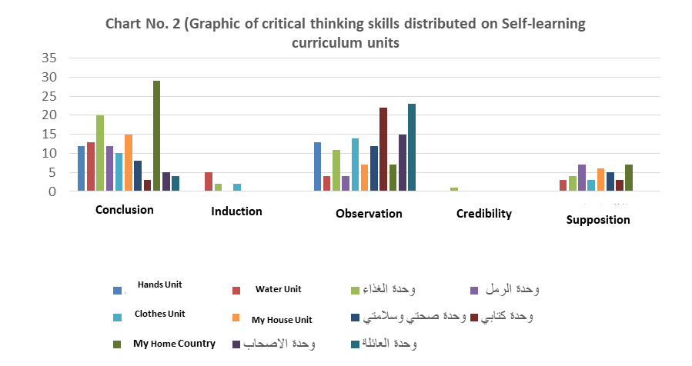
Chart (2) and (3) state that the family unit questions scored highest duplications, as it focus on exciting and developing observation skill at (22) duplications, followed by My book unit @ (22) then friends unit @ (15) while notable decrease was noticed in my house and home country units which scored (7) duplications. In the same time water, sand units generated 4 duplications which is law rate in raising its questions on observation skill. Family unit questions depended on many classification and serial order compared to my book and my friend units.
My Friends Unit
Food Unit
My Health-Safety Unit
Family Unit
Sand Unit
My Book Unit

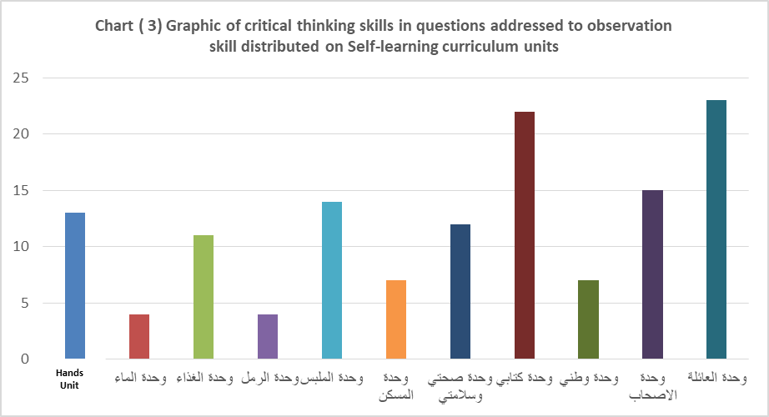
Water Unit
Food Unit
Sand Unit
Clothes Unit
My House Unit
My Health-Safety Unit
My Book Unit
My Home Country Unit
My Friends Unit
Family Unit
Chart (2) and (4) state that My homeland unit questions scored highest duplications, as it focus on developing induction skill of critical thinking @ (20), followed by food unit @ (20) then house unit @ (15), while notable decrease was noticed in induction skill of critical thinking in friends unit @(5) followed by family unit @(4). My book unit scored the last rank @ (3). Induction skill depends on addressing examples and extracting main idea and interpretation skill. Inquiry is raised to family, my book and friends units scored high degree of observation while induction skill is law…. Also my homeland unit scored induction skill at high level compared to its low duplications in observation skill.
Hands Unit

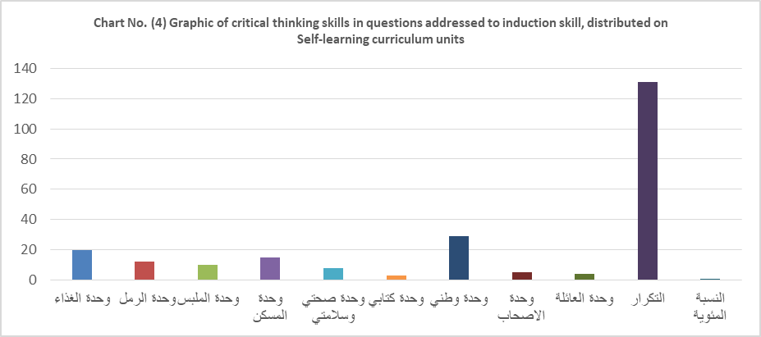
Duplication
Food Unit
Sand Unit
Clothes Unit
My House Unit
My Health-Safety Unit
My Book Unit
My Home Country Unit
My Friends Unit
Family Unit
Percentage

Also charts Nos. (2) And (5) explain that questions directed to self-learning curriculum units did not support children education in terms of assumptions skill. The highest duplications were scored for my homeland and Sand units @ (7), representing low duplication range compared to that of observation and induction. No duplication were noticed in hands, friends and family units; @ (zero) duplications. The foregoing reflects basic objective of kindergartens and nursery schools in education police at KSA, represented by encouraging creative activity of the child, fulfilling the childhood needs, enhancing its senses and finally training the child to use thereof in adequate manner. The basic aim of assumptions skill is to present opinion, probability and raise the matter of (what if).

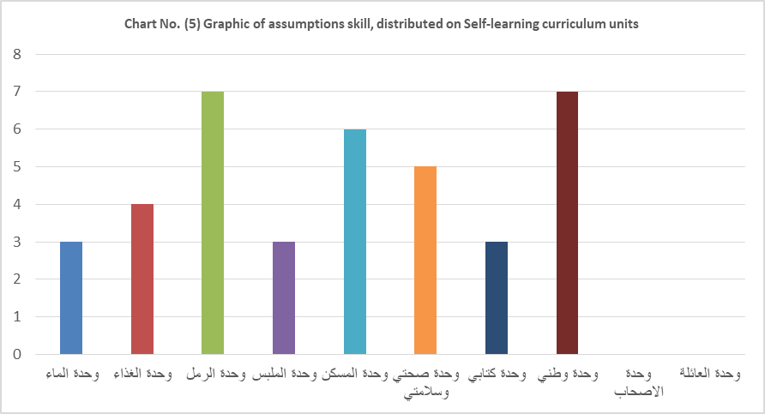
Food Unit
Sand Unit
Clothes Unit
My House Unit
My Health-Safety Unit
My Book Unit
My Home Country Unit
My Friends Unit
Family Unit
Water Unit
Chart No. (6) Explains conclusion skill of the educational units questions; water unit scored (5) followed by food and clothes unit (2), while the remaining educational units scored (zero) in its repetitions, as displayed in Chart No. (6). Notable decrease trend was noticed in supporting educational units questions in terms of credibility skill; food unit scored (1) only, while the remaining units scored (zero) as displayed in chart No. (7).
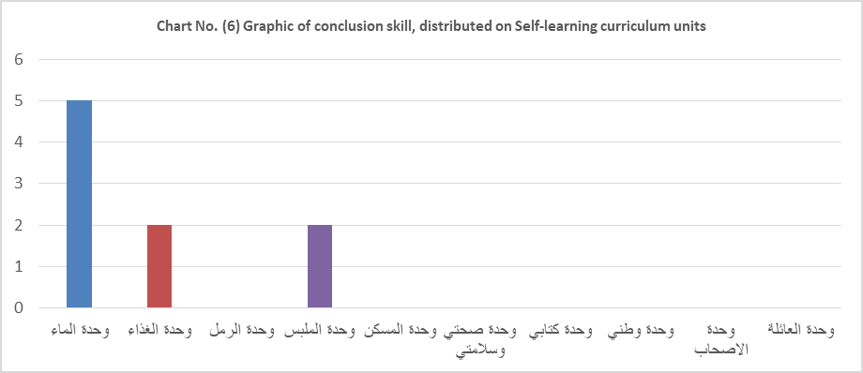
Food Unit
Sand Unit
Clothes Unit
My House Unit
My Health-Safety Unit
My Book Unit
My Home Country Unit
My Friends Unit
Family Unit
Water Unit

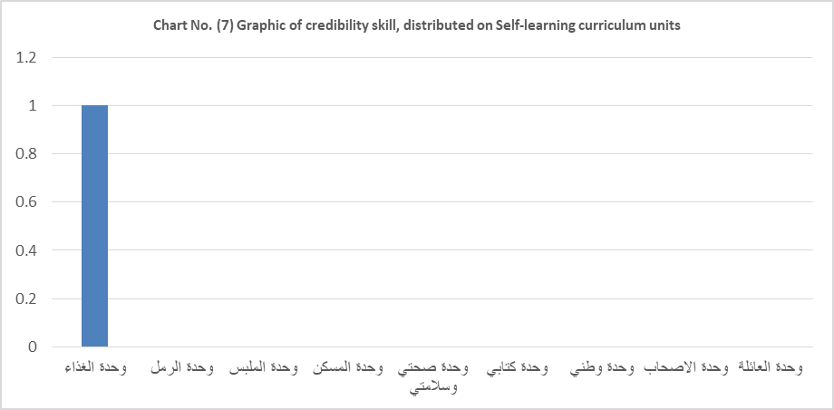
Food Unit
Sand Unit
Clothes Unit
My House Unit
My Health-Safety Unit
My Book Unit
My Home Country Unit
My Friends Unit
Family Unit

From the above charts it is obvious that conclusion and credibility skills scored weak activation in questions directed to self-learning units, as it depend on reaching to the information, assuring thereof, indentify its source or defining connection trends & identifying the evidences. The foregoing may be early as to children of 3-6 years old, but they may be developed gradually. Also researchers assured that the basic knowledge is necessary if the students want to display their skills in critical thinking (case, 2005; Willingham, 2007). On the other hand, the foregoing raises a question of what Elder & paul, 2012) & Broadbear & Keyser, 2000) reached at; that the thinking contains all these factors and it is important to cover each factor to be able to think of more complicated matters. Moreover, Marzato and others assured that each skill shall be presented to the child to recognize thereof and help them to develop strategies that assist them to use thinking supreme skills.

From the above, we can say that self-learning units curriculum encourage supporting induction in (food, life in house and my homeland units) and observation skill in (Family, my book and clothes units). While on the subject, all educational units, do not second credibility and conclusion skills and seconding assumption skill in weak manner. The educational units designers and self-learning curriculum developers have to consolidate thinking skills in this critical stage of human life; childhood stage. The children in such stage learn there personality modes and form various skills for thinking, in particular critical thinking skills, in an environment where social and cognitive theories call to educate the children and communicate with them to enhance all skills.

Recommendations

- Reviewing the developing the educational units of self-learning curriculum to support critical thinking skills in all units in terms of all respective skills.

Suggested researches

- Conducting researches in critical thinking development, at kindergarten children.
- Developing other field and applied researches to measure the impact of self-learning curriculum of critical thinking skills and comparing thereof to other curriculums of same age stage children.

Thankfulness and appreciation

The researcher herein extends her thankfulness and appreciation to Professors; Amani Al Majei' Aseeri and Prof. Huda Hassan Al Olaqi for their appreciated help offer to the researcher in the field analysis.

References

Ibrahim, Majdi Aziz (2005) – creative teaching and thinking learning, Egypt , book world

Abu Jado, Salih M. Ali and Nofal, Moh'd baker (2007) thinking education, theory and application, Amman Jordan, Maseerah house for publishing and distribution

Al Asta, Hind (2008) critical thinking skills included in literature and texts curriculum level of 11th. class and the extent of students acquisition thereof, MS degree Islamic University, Gazza, Palestine.

Ambo Saaidi, Abdallah Ben Khamees and Suleiman, Moh'd Ben Al Bloushi (2011) methods of teaching sciences, practical and applied concepts. (Edit 2) Amman, Jordan, Al Maseerah house.

Jarwan, Fathi Abdel Rahman (2007) teaching thinking; concepts and applications, Edit (3) Fikr house, Amman

Al Harahshah, Kawther abbood (2014), Impact of standing educational program on imagination strategy in teaching sciences within critical thinking development of fundamental stage students in Jordan. Arab Universities union magazine, for education and philosophy 12(1), 188-221.

Al Hisan, Amani Moh'd, (2012), suggested program in science on impact of learning introduction, and cleverness various theory on scientific cleverness abilities and life skills of Riyad Kindergarten children, Educational magazine 104, (2), 289-338

Darwazeh, Afnan Natheer, 2000, theory of teaching and translating thereof practically. Amamn Shrouq house for Publ. and Distrib.

Zaytoon, Ayesh Mahmoud (2007); Constructive theory and strategies of teaching sciences. Amman, Shorouq house for pub. And distrib.

Shehatah, Hassan and Al Najjar, Zainab 2002) critical thinking at 1st. secondary class students in Riyadh city and its relationship with variables. Educational and psychological sciences magazine, 6th. volume 2nd. edit 89-116

Sabri, Maher Ismail (2008) education's curriculums and systems, Al Riyadh, Al Rushd library.

Obaid, William, Afanah Ghazzo (2003) efficacy of some scientific activities on developing creative thinking abilities at kindergarten children in Mecca city. MS thesis – not published, Om Al Qura University.

Owais, Razan (2009) efficacy of kindergartens teachers' training program on developing some thinking skills of kindergarten children, Semi-experimental study on Kindergartens teachers in Damascus, students ages are ranged from 5-6 years old. PhD thesis , unpublished, Damascus University.

Qattami, Nayfeh, 2004, thinking education directed to basic educational stage, Edit 2, Al Fiker house, Jordan

National center for measurement and evaluation in higher education (1436) standards of kindergarten teachers, vocational standards project directed for teachers, as well as evaluation tools, Educational services development co.,

Al Mansour, Ghassan Moh'd (2005) efficacy of thinking skills development program linked to problems solving, semi – experimental study on students sample selected from 6th. basic class in Damascus region. PhD thesis, unpublished, University of Damascus

Mansi, Abeer Mahmoud (2000), efficacy of some scientific activities in creative thinking abilities development of kindergarten children, MS thesis, unpublished, High studies institute for childhood, Ein Shams university

Meena, Fayez marid (2003) Causes in educational curriculums, Cairo, Anglo Egyptian library

Nabhan, Yehya (2008), Brainstorming and problems solving, Amman, Jordan. Yazoori house for Pub. And distr.

Al Hashemi, Abdel Rahman and Mohsaen, Ali Atiah (2009) analyzing Arabic language purport curriculum, theoretical applied vision, Jordan, Al Safaa house for Pub. And dist.

Ministry of Education (2015) standards of creative early learning for ages from 3-6 years old, Educational services development co.

Foreign References

Abrami, P. C., Bernard, R. M., Borokhovski, E., Wade, A., Surkes, M. A., Tamim, R., & Zhang, Dai. (2008). Instructional interventions affecting critical thinking skills and dispositions: A stage 1 meta-analysis. Review of Educational Research, 78(4), 1102–1134.
Bahatheg, R. (2010). How the use of Montessori sensorial material supports children’s creative problem solving in the pre-school classroom. PhD Thesis. University of Southampton.
Baroody, A. (2000). Does mathematics instruction for three- to five-year-olds really make sense?. Young Children, 7(4), 61-67.
Beyer, B. (1985). Critical thinking: What is it?. Social Education, 49, 270-276.
Bose, K. (2012). Scientific thinking in preschools of Botswana: Is It possible?. European Journal of Educational Studies, 4(3): 411-435.
Brink-Budgen R (2000) Critical Thinking for Students. 3rd edn. HowtoBooks, Oxford.
Bruner,J.(1966).Toward a Theory of Instruction. Cambridge: Harvard University Press.
Bruner,J.(1996). Constructivist Theory. Net.
Caillard, F. (1993). A content analysis of the appropriateteness of kindergarten curriculum and curricular materials for high-ability students. Ph.D. Thesis, University of Connecticut.
Case, R. (2005). Moving critical thinking to the main stage. Education Canada, 45(2), 45–49.
Castle A (2009) Helping health professional students develop their critical thinking skills. International Journal of Therapy and Rehabilitation, 16(11): 582–3
Castle, A. (2010). Comparing and contrasting health profiles: one dimension of critical thinking. International Journal of Therapy and Rehabilitation, 17 (7).
Chen, Z., & Klahr, D. (1999). All other things being equal: children’s acquisition of the control of variables strategy. Child Development, 70, 1098–1120.
Collier, K., Guenther, T., & Veerman, C. (2002). Developing critical thinking skills through a variety of instructional strategies. Master’s thesis. Saint Xavier University. Chicago, Il.
Cottrell S (2005) Critical Thinking Skills: developing effective analysis and argument. Palgrave MacMillan, Basingstoke.
Costa, A.L., & Kallick, B. (2008). Learning and leading with habits of mind: 16 essential characteristics for success. Alexandria, VA: ASCD.
Costa, A.L., & Kallick, B. (2009). Habits of mind across the curriculum: Practical and creative strategies for teachers. Alexandria, VA: ASCD.
Facione, P. A. (1990). Critical thinking: A statement of expert consensus for purposes of educational assessment and instruction. Millbrae, CA: The California Academic Press.
Facione, P. A. (2000). The disposition toward critical thinking: Its character, measurement, and relation to critical thinking skill. Informal Logic, 20(1), 61–84.
French,J.& Rhode,C. (1992). Teaching thinking skills theory and practices. New York: Garland and Publishing, INC.
Gelman, S. A., & Markman, E. M. (1986). Categories and induction in young children. Cognition, 23, 183–209.
Hashim, R. (2002). Investigation on teaching of critical and creative thinking in Malysia. Journal Pendidikan Islam. 10, 39-56.
Kennedy, M., Fisher, M. B., & Ennis, R. H. (1991). Critical thinking: Literature review and needed research. In L. Idol & B.F. Jones (Eds.), Educational values and cognitive instruction: Implications for reform (pp. 11-40). Hillsdale, New Jersey: Lawrence Erlbaum & Associates.
Kuhn, D.(2005). Education for Thinking. Harvard University Press.
Klahr, D., & Nigam, M. (2004). The equivalence of learning paths in early science instruction: Effects of direct instruction and discovery learning. Psychological Science, 15, 661–667
Lamper, N. (2011). A study of an after-school art programme and critical thinking. International Journal of Education through Art, 7 (1): 55-67.
Lauren, M & Michael. (2004). Critical thinking across the curriculum project. Retrieved March,2017, http://documents&setting/useri/desktop/critation.htm.
Lipman, M. (1988). Critical thinking—What can it be? Educational Leadership, 46(1), 38–43.
McGuinness, C., Sheehy, N., Curry, C., Eakin, A., Evans, C., & Forbes, P. (2006). Building thinking skills in thinking classrooms. ACTS (Activating Children’s Thinking Skills) in Northern Ireland. London, UK: ESRC’s Teaching and Learning Research Programme, Research Briefing, 18.
Michael et. al. (2005). Critical Thinking, Wisconsin Historical Society", 2005, at available: www.wisconsinhistory.org.P.24,25. www.LlacodencBrooklyn.cumy.edu/geology/leveson/linksa/
Miller, M. & Olthouse, J. (2013). Critical thinking in gifted children’s offline and online peer feedback. Contemporary Educational Technology, 4 (1): 66-80.
Neuman, E.P.(1978). The Torrance tests of Creative thinking. Technical norms manual.
Paul, R., & Scriven, M. (1987). Critical thinking as defined by the National Council for Excellence in Critical Thinking, 1987. Statement presented at the 8th Annual International Conference on Critical Thinking and Education Reform, Berkeley.
Pithers, R. T., & Soden, R. (2000). Critical thinking in education: A review. Educational Research, 42(3), 237–249.
Ramsay, P., et.al. (2009). Blooming with the pouis: Critical thinking, reading and writing across the curriculum. Miami, Florida: Ian Randle.
Richardson, V. (2005). The diverse learning needs of students. In D.M. Billing & J.A. Halstead (Eds.), Teaching in nursing. A guide for faculty. (2nd ed., pp.21-37). St. Louis,MO: Elsevier Saunders.
Rogoff, B., (1990). Apprenticeship in thinking, cognitive development in social context.USA: Oxford University Press
Silva, E. (2008). Measuring Skills for the 21st Century [Report]. Washington, DC: Education Sector. Retrieved from http://www.educationsector.org/usr_doc/MeasuringSkills.pdf.
Stewrt, S. & Dempsey, L. (2005). A longitudinal study of baccalaureate nursing students’ critical thinking dispositions. Journal of Nursing Education, 44, 81-84.
Thomson (2002). Critical Reasoning: a practical introduction. Routledge, London.
Tobin, K.& Capie, W. (1982). Development and validation of group test of integrated. Science Process. Journal of Research in Science Teaching, 19(2), 133-144.
Udall, A.J., and J.E. Daniels. (1991). Creating the thoughtful classroom. Zephyr Press, Tucson, AZ.
Vygotsky, L. S. (1978). Mind in society: The development of higher psychological processes. Cambridge, MA: Harvard University Press.
Watson, G., & Glaser, E. M. (1994). Watson-Glaser Critical Thinking Appraisal, Form S manual. San Antonio, TX: The Psychological Corporation.
Whitehead, T. D. (2006). Comparison of native versus nonnative English-speaking nurses on critical thinking assessments at entry.
Wilson, V. (2000). Can Thinking Skills be Taught? Scottish Council for Research in Education. May. Scottish Executive Education Department, Edinburgh.
Willingham, D. T. (2007). Critical thinking: Why is it so hard to teach? American Educator, 8–19.
Worrow. (2004). Reflection and critical reasoning in education contexts. In: A Coles ed. Teaching in Post-Compulsory Education (155171). David Fulton, London

